**CIT360 Maze Application**

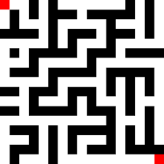**Project**

Write an application that applies both DFS and BFS algorithms to find paths between two points in a maze. Your application needs to take the following specific steps:

* Generate a random size 2D maze.
* Pick two random points on the maze as start and finish points.
* Use Depth First Search algorithm to find a path from the start to fish points.
* Use Breadth First Search algorithm to find a shortest path from the start to fish points.
* Draw (print) the found paths.
* Application should also respond correctly if there is no path between the end points.

**Helpful Notes:**

* Use a parallel 2D array of Booleans to keep track of the visited cells
* Use a class similar to Java API java.awt.Point to represent a point on the maze. Alternatively, write your own point (cell) class.
* As you are performing the breadth-first search via queue, keep track of the visitation distance of each cell that you visit in a parallel 2D array of integers. You can use this array to trace your path back to start from the finish point.
* Maze density is between 0 (no blocked cells at all) and 1 (complete blockage of all cells). Use a density that provides viable mazes.
* Optionally, place blocked cells on the exterior walls of your maze to help you stay inside the maze.